Isaac Phiri  
ST10074970  
INSY7

Question 1

Qiestion 2

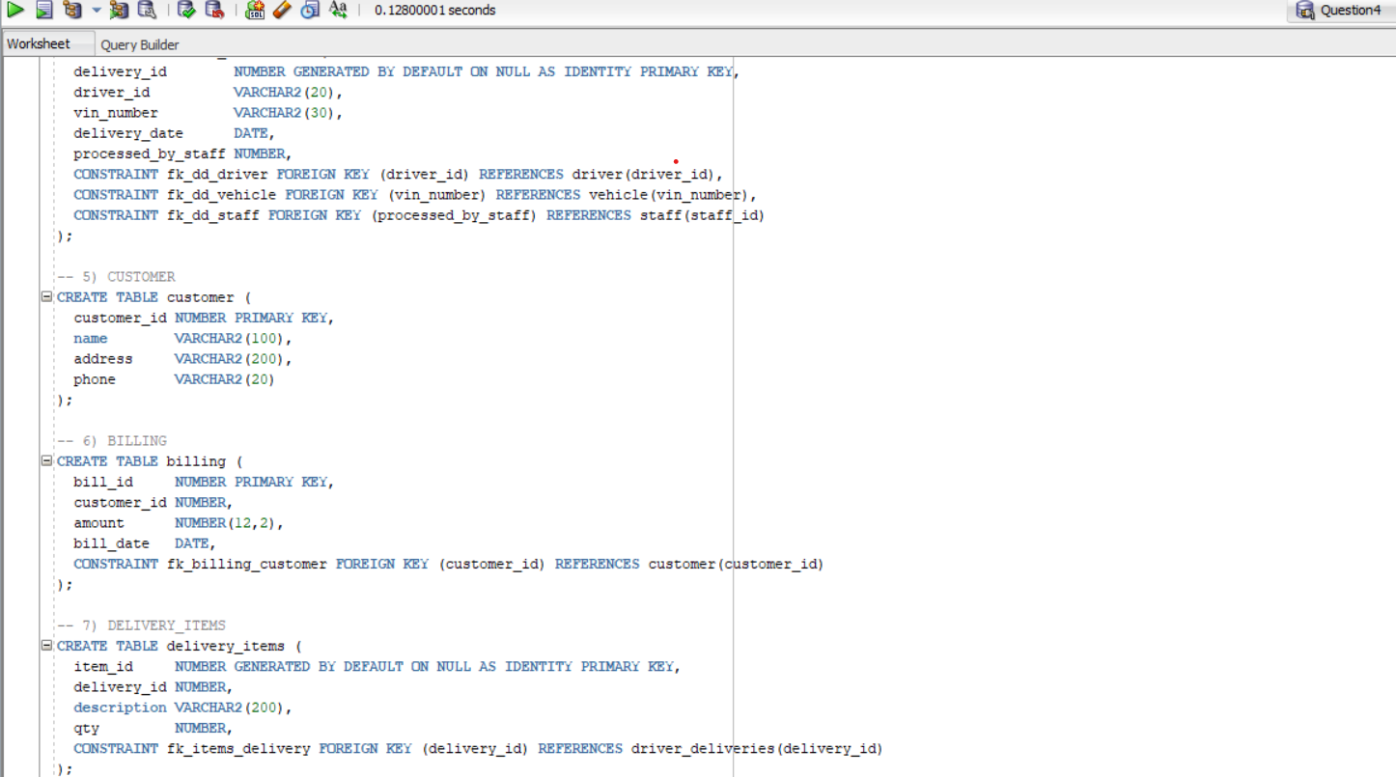

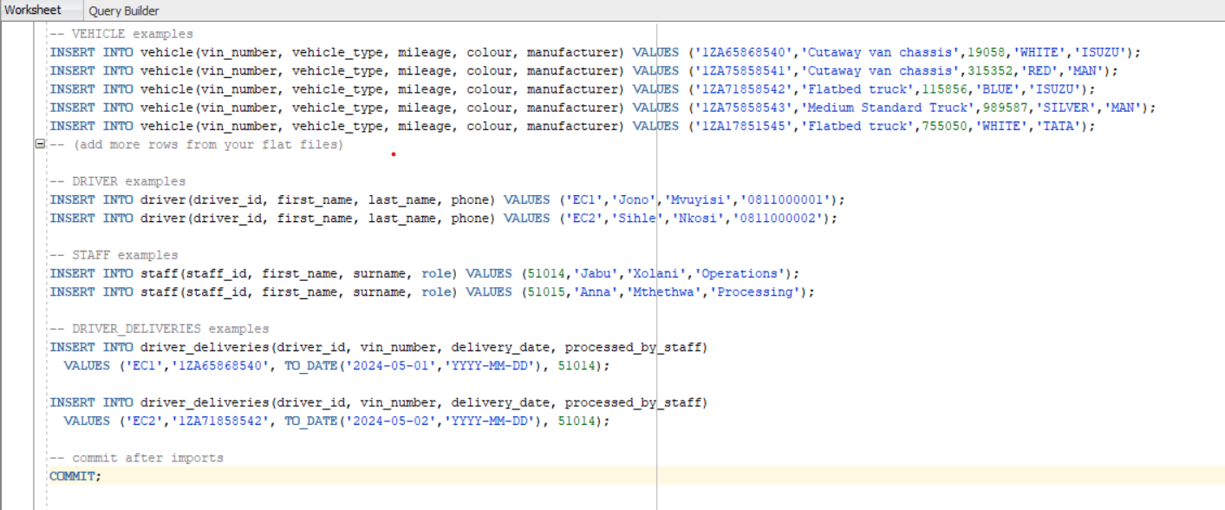

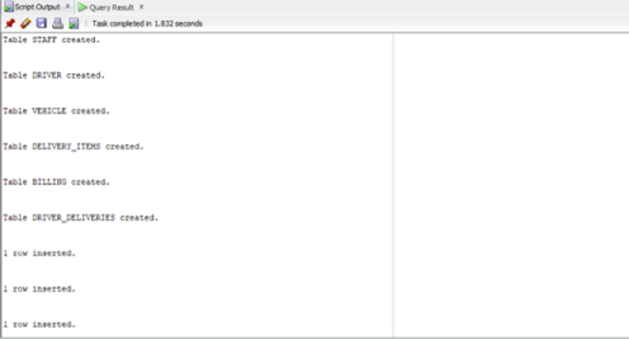

Question 3

3.1)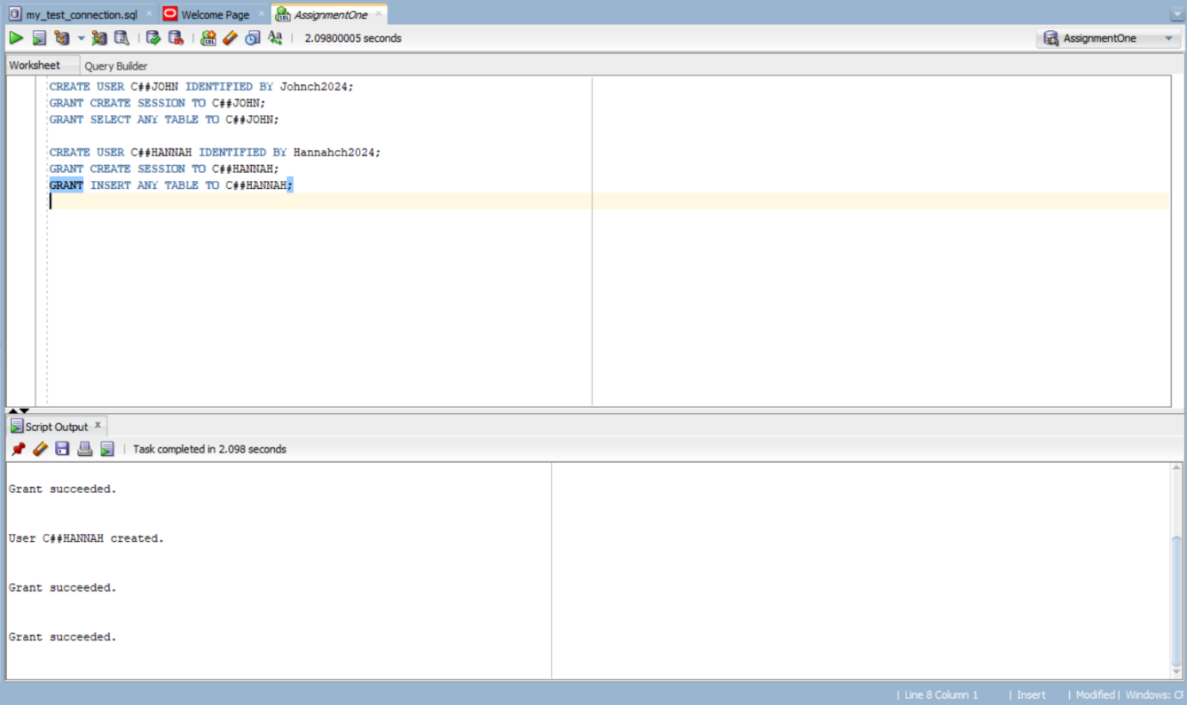

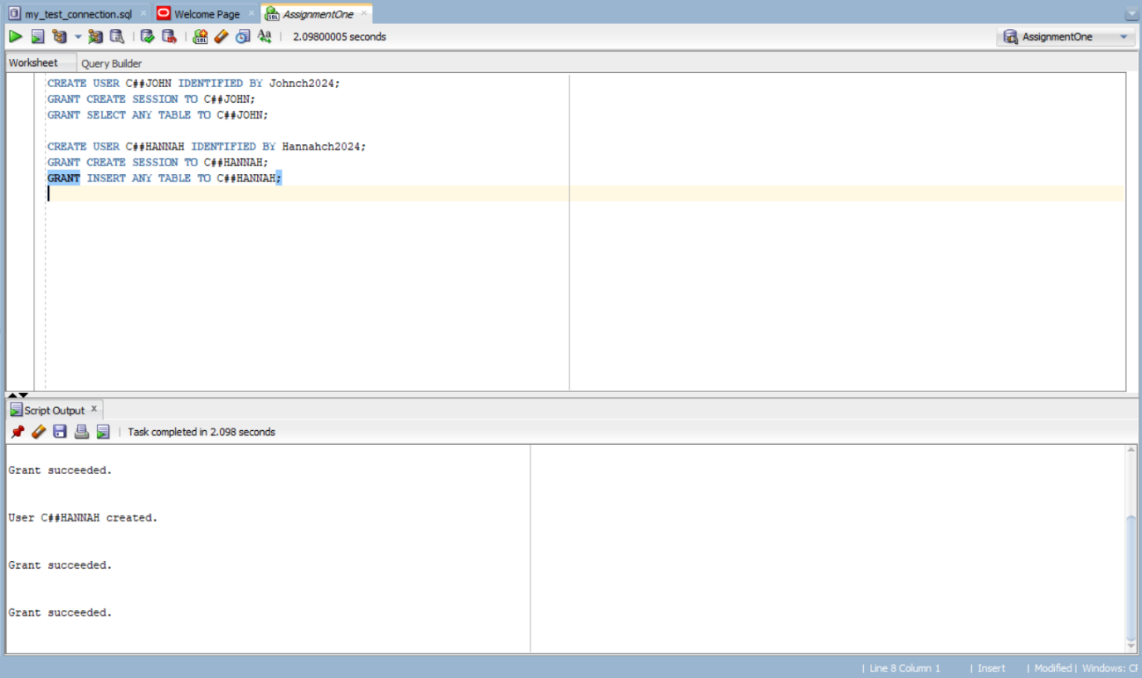3.2)

John has read-only access so he can query data but cant change it

Hannah has insert privilege so that she is able to add records but cant in this configuration

Separation of duties reduces fraud risk while still preserving data integrity and still pushing accountability.  
  
Question 4

Question 4

4.1) 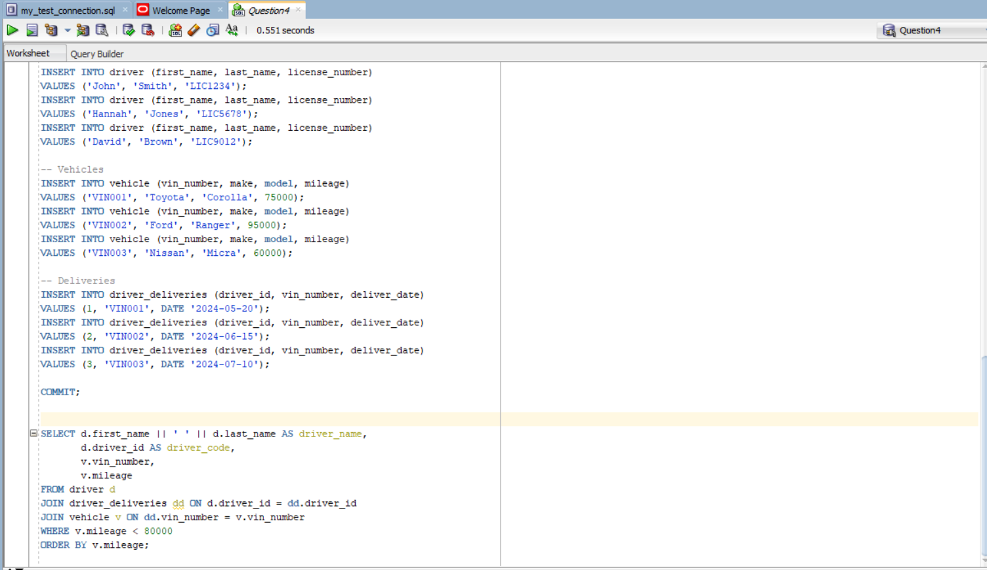

4.2) • Flat files: single-table text files redundant data, duplication leads to update anomalies.

• Relational model: normalized tables, keys, and constraints help make sure data integrity and eliminate duplication, allows for powerful SQL joins, indexes, and transaction control.

• For Cheetah Deliveries, relational design supports multiple user transactions like deliveries, billing, easy reporting of driver/vehicle reports and enforcement of business rules via constraints.

Question 5

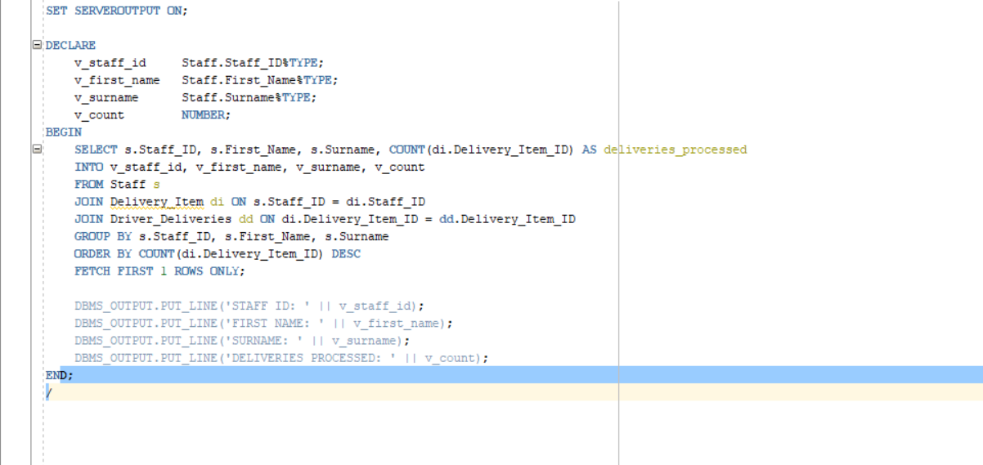  
  
5.2 PL/SQL blocks have three sections:

1. Declaration section → variables, constants, cursors, data types.

(In Q.5.1: we declared v_staff_id, v_first_name, v_surname, v_count).

2. Execution section → contains the main SQL/PLSQL logic.

(In Q.5.1: the SELECT INTO ... query and the DBMS_OUTPUT.PUT_LINE commands).

3. Exception-handling section → handles errors gracefully.  
  
5.3.1   
A view is a stored queary that also acts as if it was a virtual table.   
5.3.2

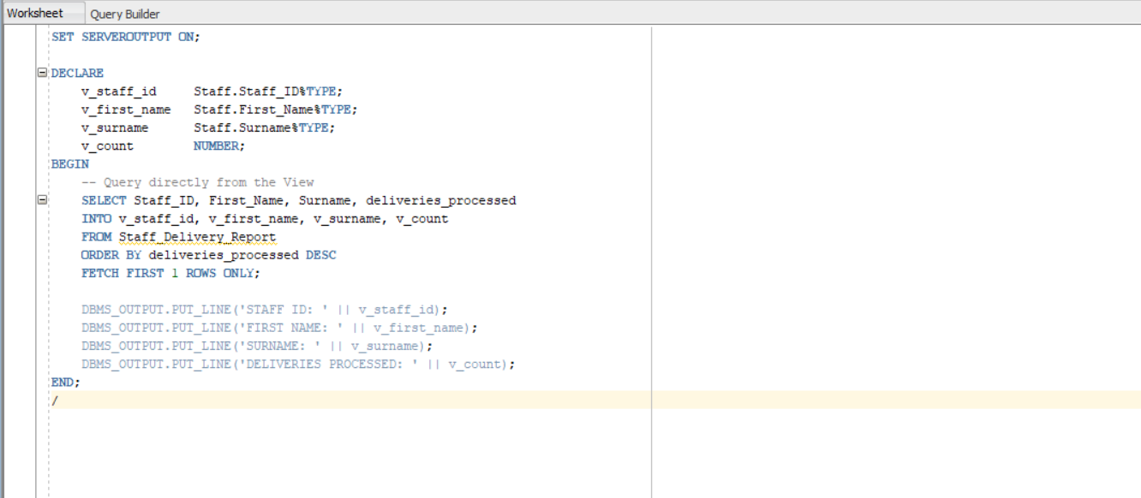  
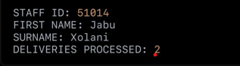

Question 6 .1

Implicit cursor attributes

Is used when oracle does a sql statement automatically, it also proves information about what the last executed statement is.  
FOUND → Returns TRUE if at least one row was affected.

• %NOTFOUND → Returns TRUE if no rows were affected.

• %ROWCOUNT → Returns number of rows affected.

• %ISOPEN → Always FALSE for implicit cursors.

Explicit curor attributes

Declared by the user for more control when getting more rows.

Useful when working with multiple row queries like iterating through all deliveries

A

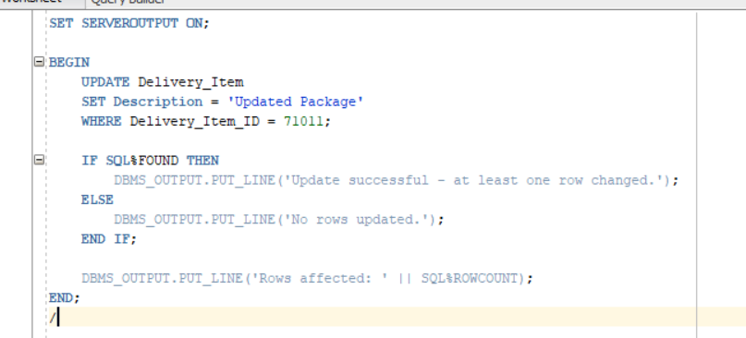

**B**

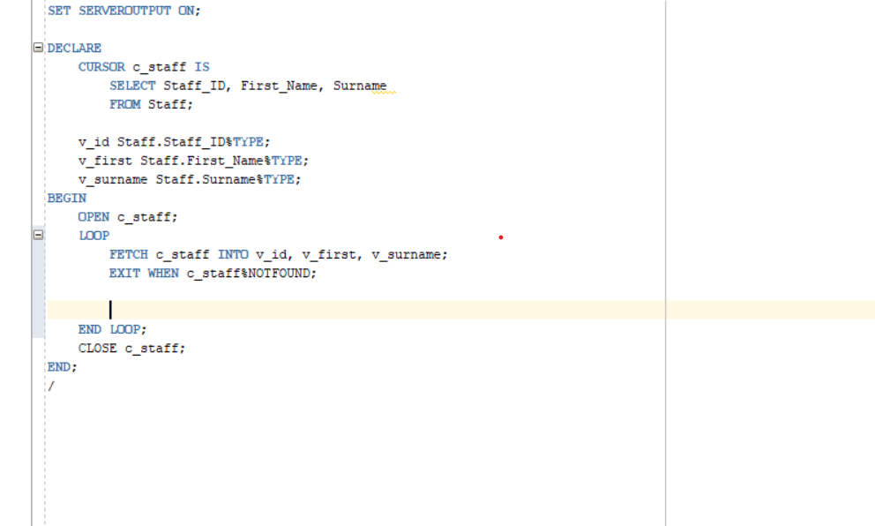

**6.2**

**A sequence is a database object that generates unique numbers automatically. It is useful for generating primary keys (like Staff_ID, Delivery_Item_ID, etc.) without manual input.**